370 Dudley Hill Road
Bradford, BD2 3AA
Tel: 01274 643576
Fax: 01274 643317
www.moorsidesurgery.nhs.uk B83056.moorside@nhs.net

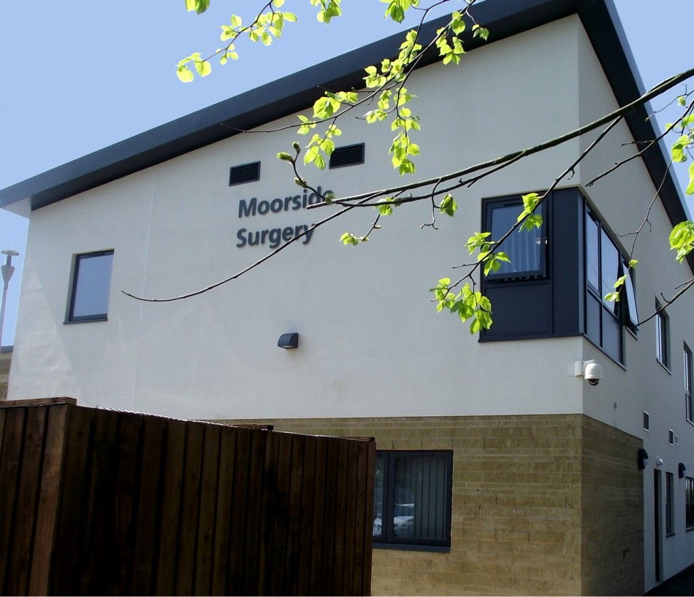
Practice Leaflet

Welcome to Moorside Surgery
The Moorside Practice Team

The Partners - (Moorside Surgery is not a limited partnership)
Dr Elizabeth Pennington [female]
MB ChB Leeds 1989 MRCGP

Dr Jonathan Dixon [male]
MB ChB Leeds 1993 MRCGP

Dr Louise Gazeley [female]
MB BS Newcastle 1997 MRCGP – GP trainer

Dr Alicia Taylor [female]
MB ChB Leeds 2006 BSc (Hons) MRCGP DFSRH

Dr Seemab Khan [female]
MB BS London 1997 MRCGP
Employed General Practioners
Dr John Sullivan [male]
MB ChB Leeds 1987 MRCGP DRCOG

Dr Kay Kennis [female]
BMBCH Oxford 1999 MRCP DRCOG

Dr Humaira Rashid {female}

The Nurses
Sister Rebecca Maney – Senior Practice nurse
Sister Cheryl Sargeant – Practice Nurse
The HCA’s
Helen Smorzaniuk – Healthcare assistant
Linda Phelps – Healthcare assistant
Julie Archenhold – Healthcare assistant
Olivia Coley-Walsh – Healthcare assistant
The Pharmacist
Caroline Dixon
The Practice Manager
Collette Ross
Reception Team
Reception Times
Monday 08:00am to 18:30
Tuesday 08:00am to 18:30
Wednesday 08:00am to 21:00
Thursday 07:30am to 18:30*
Friday 08:00am to 18:30

* We are closed every 4th Thursday – 13.00 to 16.00 Thursday for staff training
* Our telephone lines close daily between 13.00 to 14:00 and from 18:00 to 08:00 the next morning
*We are closed bank holidays unless otherwise stated

Appointment Times
GP appointments at Moorside
Routine appointments with a GP of your choice may be booked in advance and appointment slots are normally provided from 08.30 until 10.30 and between 15.00 and 17.30. We can sometimes offer bookable GP appointments outside these times – please ask reception for details.

The following table shows (marked in green) which GPs are normally available for routine appointments during the week:

Please be aware that the information shown above may be subject to change.

Urgent Care appointments
Available daily from 10.30 - after the doctors’ morning surgeries to enable patients with urgent problems to be seen the same day

Requests for urgent care appointments should be made by 10:30 and there could be a lengthy wait to be seen.
It is not possible to specify which GP will see you but you can ask to be seen by a male or a female GP if necessary
Please be aware that you will be asked for a brief description of the problem when asking for an urgent care appointment -so we can direct you to the best service - you are not obliged to provide this information if you’d prefer not to but it would help.
All information is confidential and employees are duty bound.

GP telephone appointments
Telephone appointments are also available to book for issues which don’t require a face-to-face consultation. A GP will ring you on the agreed date and we can usually give you an indication of the approximate time of the call.
If you miss your call we may not be able to call again

EXTENDED ACCESS SERVICE – Information for patients

This practice is part of the extended access service which provides GP, Physiotherapy, Nurse, and Health care assistant appointments from the following locations (hubs) across Bradford:

We also host extended at Moorside Surgery on a Wednesday evening between 18:30pm and 21:00pm

North hub: Shipley Medical Practice, Alexandra Road, Shipley, Bradford BD18 3EG
Central hub: Picton Medical Centre, Westbourne Green Community Health Care Centre, Manningham, Bradford, BD8 8RA
South hub: The Ridge Medical Practice, Cousen Road, Bradford, BD7 3JX

As a patient registered with this practice, you have access to the following:
Weekday appointments
Evening appointments (6.30pm – 9.30pm) at any of the fourhubs to see one of the following, subject to availability:

GP
Physiotherapist
Nurse
Health care assistant
Voluntary sector services

Extended Access Weekend appointments
Weekend appointments are available with a GP from 10.00am - 1.00pm on Saturdays and Sundays from the central hub, subject to availability.

More information about appointments with the extended access service

The service is run by Bradford Care Alliance, which represents all GP practices in the Bradford area. Medical appointments are with GPs and other healthcare staff who work in the area; so your appointment may not be with a clinician from this practice.

To use the service we will ask for your consent to share your medical record and our reception staff will explain what this means and why it is necessary.

Physio First
The Practice has on-site physiotherapists who can manage clients with a wide array of conditions from sports injuries to those with back and neck pain.
In the first instance we will offer physio first rather than a GP who will assess you.
If the physio feels you need to see a GP for your condition or medication they can arrange this at the Surgery.

General practice training scheme
Moorside Surgery is a training practice. This means that doctors with experience of working in hospitals and other practices spend time with us to gain additional experience of general practice as GP Registrars. Therefore you may possibly be offered an appointment with a GP Registrar; please be assured that a GP Registrar is a qualified doctor fully responsible for their own consultations.
We are also committed to the training and development of the next generation of GPs and we appreciate the co-operation of many of our patients who support us in this aim. You may find that you are asked if a medical student can be present during your consultation (sometimes we ask if a student may lead the consultation under the supervision of a GP). Your co-operation is entirely voluntary; please advise reception if you do not wish a student to be involved with your consultation.

Practice pharmacist
Our practice pharmacist provides expert advice on medicines to clinicians. She is also available for telephone consultations if you have a query regarding your medication.

Nursing team
The nursing team provide an additional service to the doctors by carrying out:
New patient registration checks
Childhood immunisations
Cervical smears
Ear Syringing
Chronic disease monitoring clinics such as Asthma, Diabetes, COPD etc
Dietary and smoking advice
Anti-coagulation clinics
Contraceptive clinics
Blood pressure checks and blood tests
Travel vaccinations

Please contact reception to book an appointment with a member of the nursing team.

Business manager
The business manager, Mrs Collette Ross, is responsible for organising the smooth running of the practice, whilst focusing on finance and strategy. She will deal with any comments, queries or suggestions that patients may have relating to non-medical matters.

Administration/Reception team
Our experienced admin team/reception team have a complex role supporting the clinicians and patients. In addition to providing a friendly and helpful service at reception they ensure that correspondence relating to patients is processed efficiently.

The team can deal with many issues on the telephone to save your having to come to the surgery; this can apply to blood test results, x-ray results, medication advice, fit notes etc. (please note that, for patient safety reasons, they are unable to take repeat prescription requests over the phone). You may find it easier to get through on the phone if you delay phoning the surgery until after 10.00.

Medical secretaries within the admin team handle the paperwork when the GPs refer patients to hospitals and other services and deal with any resulting queries from patients.

We kindly request that you show respect to all our staff, they are there to help you. Verbal or physical abuse of any kind is treated extremely seriously and could result in your removal from the list of patients registered at Moorside.

When the Surgery is closed
For emergencies that cannot wait until the surgery is open, please telephone 111 (Freephone) and your call will be put through to the out-of-hours service. Please remember that this service is there only to provide urgent medical attention. If the service is abused by calling the doctor for minor illnesses then other patients could be put at risk.
The Out of Hours service is commissioned by NHS Bradford Districts CCG and is provided by Local Care Direct (tel: 0845 120 7066) as follows:
Monday to Friday, 18.00 - 08.00 (Thursday 13.00-16.00)
From 18.00 Friday to 08.00 Monday
Late Arrivals
If you are late for your appointment, you may be asked to rearrange your appointment for another day.
Cancellations If you are unable to keep your appointment, please let us know as soon as you are able so that the time can be given to another patient.
Missed Appointments Policy
Moorside Surgery is dedicated to providing a high standard of care and services to all our patients. One extremely important factor is making sure we have enough appointments and missing an appointment without telling us is not acceptable.
First Missed Appointment
If you do not come to an appointment, or if you cancel your appointment at such short notice that we are unable to offer it to another patient, you may receive a warning letter.
Second Missed Appointment
If you miss two appointments you will receive a warning to say that if you miss any more appointments you will be taken off our medical list.
Third Missed Appointment
Your name will be removed from our list unless there are exceptional circumstances to be considered. The doctor would then make a decision accordingly.
Home Visits
A home visit should only be requested for patients who are genuinely too ill to attend surgery. It takes at least four times longer to see a patient at home than it does in surgery; please help us to help you and our other patients by visiting the surgery whenever possible.
Please be ready to give details of name, address, telephone number and the nature of the illness. This assists the doctors in arranging their visit list.
All requests for home visits should be made before 10.30 if at all possible.
Please note that not having your own transport is not a valid reason for requesting a home visit!
Provide the receptionist with some details of the problem. Change of address or telephone number
Please inform us of any change in address, home telephone number or mobile phone number. We may need to contact you urgently.
NON-NHS work and fees
The doctors are happy to carry out non-NHS work. This could include medical examinations for insurance purposes, occupational purposes, driving medicals, etc. When you make an appointment please make it clear to the staff that the appointment is for a specialised medical examination so that the appropriate length of appointment can be made. These and other services such as private certificates, letters and insurance reports are not covered by the National Health Service and a professional charge will be made. You can enquire at the reception desk for a scale of charges.
DISABILITIES
If you have a disability, please inform the receptionist and she will help you accordingly. The premises have suitable access for all disabled patients. If you have difficulty hearing we have a portable loop system which can be requested at the reception desk

Registration of new patients
To register as a patient at the surgery you must complete various items of paperwork (obtainable from reception) include a GMS1 form, a Moorside medical questionnaire and consent forms relating to how we may share your data. You will be invited to make an appointment with one of our health care assistants.
Please note that only people living within the boundary of our practice area can be accepted onto the list. You will be asked for proof of your residency within the practice boundary as well as proof of your identity.
Non UK residents not entitled to free NHS care can be seen as private patients - please ask at reception for further information and a price list.

FOR SAFETY REASONS WE DO NOT TAKE PRESCRIPTION REQUESTS OVER THE TELEPHONE
Repeat Prescriptions
If the doctor agrees, you may be able to obtain repeat prescriptions from reception.
You can do this by:
- Ordering over the internet (ask the receptionist for instructions and your password)
• Ticking the items you require on your last prescription and posting your request along with a stamped, addressed envelope. • Ticking the items you require on your last prescription and posting it in the post box in the entrance to the Surgery
All repeat prescriptions will include information as to when you need to see a doctor for a review of your medication. This is because we believe that patients on long-term medication should be seen regularly.
Please ask for our separate leaflet about repeat prescriptions. Allow 48 hours to process your repeat prescription and allow another 24 hours on top of this if you have your medication delivered by the pharmacy; remember to allow extra time for postal delays, especially on public or bank holidays. We would be grateful if you could inform the reception staff if your medication has been changed following a hospital visit.
Electronic Prescription Service
The Electronic Prescription Service allows your prescription to be sent electronically to a pharmacy of your choice. To sign up, you need to speak to your preferred pharmacy and complete a form to confirm that they can receive your prescription directly. Once you have signed up, your chosen pharmacy will receive your prescription electronically and you will not have to pick up your paper prescription from us. This service is optional and you can continue to collect paper prescriptions as you do now if you prefer. For more information, please speak to your pharmacist or a member of reception through our online services (see section below)

Online services
Our clinical computer system, SystmOne, provides on-line access for patients to book, view, amend, cancel and print appointments. It also enables patients to order repeat prescriptions online and view or print details from your medical record.
You can also view test results.
Ask reception for details of how to register to use the online services. You will be asked to provide proof of your identity before log-in details are provided.

Car parking / disabled access
Our car park has a large number of spaces; we kindly ask that you do not use the bays reserved for the doctors. We have a number of clearly marked disabled parking bays and ask that you use one of these only if appropriate. Internally, the building has been designed to be fully accessible to disabled patients.

Patient Participation Group
Our Patient Participation Group, ‘Friends of Moorside’, meets regularly to provide a forum for discussion with representatives from the practice on topics such as the range of services available at Moorside Surgery and how we handle requests for appointments. In addition there is the opportunity to represent the group at a Bradford District level. The group is open to all patients registered at Moorside Surgery.
If you would like to attend the next meeting please inform reception or contact the group directly at

Patient Health Champions
Our patient Health Champions run a variety of social events including a knit and natter club, coffee morning, trips and an allotment.
Please ask reception for details

The Moorside Surgery Patient Charter
Moorside Surgery is committed to giving you the best possible service. This will be achieved by working together. As a patient of this practice you can expect:
To be treated as an individual in a friendly, courteous and helpful manner.
Your rights to privacy and confidentiality to be respected - if you would like to speak confidentially to a receptionist please advise on arrival.
- A clear explanation of your care and treatment
- Information on services offered by the practice to be given in the practice booklet
- Your patience is appreciated as some issues may unexpectedly take longer to deal with than others.
- Repeat prescriptions ordered before 18.00 to be available for collection in two working days after 16.00.
- Unresolved complaints to be handled under the surgery’s complaints procedure

You can help us by:
- Keeping appointments with the practice and hospital, or cancelling in good time
- Requesting home and out of hours visits only when absolutely necessary
- Always informing the practice of any changes to your name, address, telephone numbers or email address – it is essential that we can contact you
- Treating the practice team with courtesy and respect
- Taking responsibility for your health by eating a balanced diet, taking regular exercise etc.
- Being responsible for your children’s behaviour whilst on the premises, ensuring their safety whilst respecting other patients’ expectations of a quiet atmosphere
We welcome your comments regarding any aspect of the service, as we continually strive to maintain and improve the service we provide.

How we use your Health Records
Everyone working for the NHS has a legal duty to keep information about you confidential. We have a duty to maintain full and accurate records of the care we provide to you and to keep records about you confidential, secure and accurate. We may share information with the following main partner organisations: strategic health authorities, NHS trusts (hospitals or primary care trusts), general practitioners (GPs), special health authorities, ambulance services. We may also share your information, with your consent and subject to strict sharing protocols about how it will be used with: social services, education services, local authorities, voluntary sector providers, and the private sector. Pick up a leaflet from reception entitled “How we use your health records” for more information. Please also see our Practice Privacy Notice on display in the reception area.
Aggressive behaviour
Moorside Surgery defines aggressive behaviour as personal, abusive or aggressive comments, bad language, physical contact or aggressive gestures. No abuse of staff is acceptable whether verbal or physical, and will be reported to the business manager.
In the case of verbal abuse, the business manager may issue an informal warning, and this may be followed up by a formal warning and a final written warning. If a patient’s conduct does not improve following these warnings, he will advise the patient that they are to be removed from the list.
Physical abuse of any of our staff will be reported to the police and the patient removed immediately from the list. If the practice has to remove a patient then alternative registration at a nominated local practice will be provided by Bradford Districts Clinical Commissioning Group.

Your local pharmacy
Help and advice with dispensed medicines
Pharmacists are trusted health professionals whose job is to help people get the best out of their medicines. They are experts in the composition and actions of drugs and will therefore be able to tell you all you need to know about your prescription medicines.
There is often a lot of information to take on board when you visit the doctor and it is only too easy to come away uncertain about how and when to take your medicines. You can be sure that your pharmacist will see that you get your medicine at the right strength and in the right dose and check that you know how to take or use it properly.
Treatment for minor ailments
If you’re feeling slightly unwell but don’t feel ill enough to go to the doctor, please do not hesitate to ask your pharmacist for advice.
Pharmacists have been trained to offer helpful, easy-to-understand advice on the treatment of everyday minor ailments for yourself and all the family – anything from headaches, coughs and colds to minor cuts and grazes, thrush or dermatitis. Your pharmacist will know when medical help is needed and will not hesitate to refer you to your doctor if your symptoms demand it.
Often an over-the-counter remedy will be all you need. It’s worth remembering that pharmacies offer far more medicines than other outlets. That’s because many of today’s effective non-prescription medicines can only be supplied under the supervision of a pharmacist.
When you ask for a medicine your pharmacist will need to ask you a few simple questions to ensure that you get the correct medicine.

The Pharmacy located within the building is a joint venture between some members of the practice team and a group of local pharmacists. This does not mean that you are under any obligation to use this pharmacy; any attempt by a member of the practice team to direct you to a particular pharmacy is a breach of NHS regulations. You are free to take your prescription to any pharmacy of your choice.

Useful Contact Numbers

Bradford Royal Infirmary | 01274 542200
St. Luke’s Hospital | 01274 734744
Bradford Hospitals Appointment Line | 01274 274274
Eccleshill Hospital Reception | 01274 323200
Emergency Dentist | 111
NHS 111 | 111
Sexual Health, Family Planning (Locala) | 03003045555
BRI Labour Ward | 01274 364514 or 364515
West Yorkshire Police [non-emergency] | 101
Jobcentre Plus | 01274 336200
Citizens Advice Bureau | 03444111444
Relate | 01274 726096
Samaritans | 01274 547547
Rape Crisis Helpline | 01274 308270
Age Concern | 01274 395144
Carers’ Resource | 01274 449660
Alcoholics Anonymous | 0800 917 7650
District Nurses | 01274 256131
Health Visitors | 01274 221223
NHS Bradford Districts CCG  Scorex House, 1 Bolton Rd, Bradford BD1 4AS | 01274 237290

Moorside Surgery
370 Dudley Hill Road
Bradford
BD2 3AA
Telephone 01274 643236
Fax 01274 643317

Web: www.moorsidesurgery.nhs.uk

